GIT ASSIGNMENT

1. Describe different branching strategies that can be used?
2. Write a command to get the list of merged/unmerged branches into a particular branch (Let us say *master* branch).

Command : git branch –r --merged

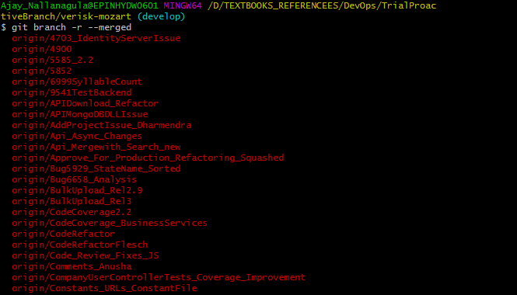

Command : git branch –r –no-merged

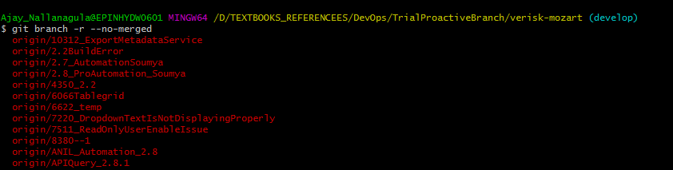

Example 2:

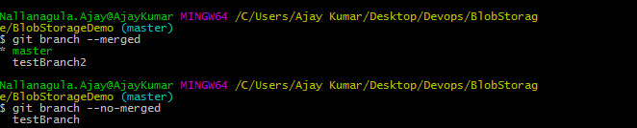

1. What is the difference between the ‘git remote’ and ‘git clone’?

Ans : The main difference between git clone and git remote is that git clone is used to create a new local repository whereas git remote is used in an existing repository. git remote adds a new reference to existing remote repository for tracking further changes. git clone creates a new local repository by copying another repository from a URL.

Reference : <https://www.youtube.com/watch?v=1urzY7u5kbo>

1. What is the difference between the ‘git diff ’and ‘git status’?

Note: you check for git diff before commiting your changes

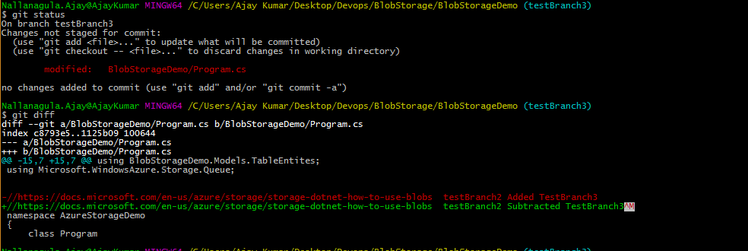

1. What is the function of ‘git rm’?

Note: first you need to add files manually , then execute git add <filename>

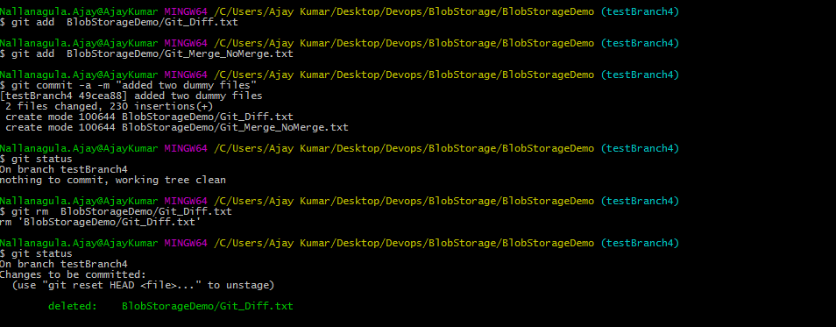

1. What is the command that is used to delete a branch (both local and Remote)?

Local branch deletion:

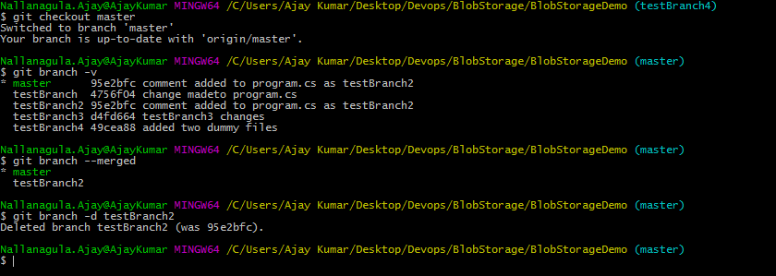

Remote branch deletion:

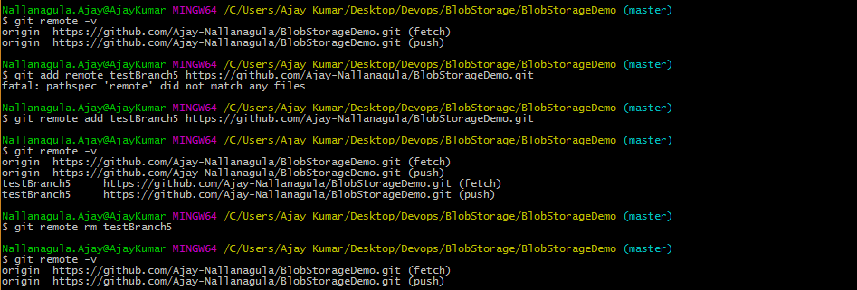

1. How do you squash last N commits into a single commit?
2. What is Git rebase and how can it be used to resolve conflicts in a feature branch before merge?
3. What are Git Submodules? Write the commands to add and drop the submodules.
4. How can you copy a commit made in one branch to another (e.g. a hot fix commit from released branch to current development branch)?
5. How do you configure a Git repository to run code sanity checking tools right before making commits, and preventing them if the test fails?